Research analyst

Research Scientist

Data engineer

Data Science

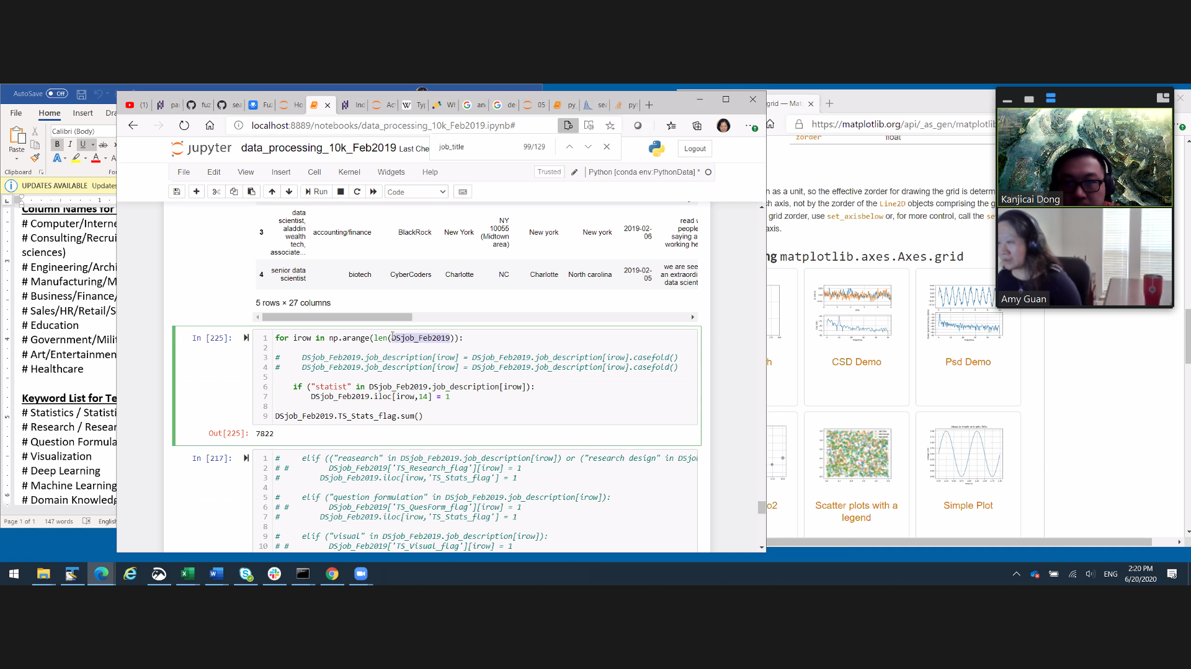

Standard Column Names

# job_title

# industry_sector

# company_name

# city

# state

# post_date

# job_description

# job_type (full-time, part-time,

contractor, others)

# salary

Column Names for industry_sector

# Computer/Internet

# Consulting/Recruiting

(life/physical/social sciences)

# Engineering/Architecture

#

Manufacturing/Mechanical/Constructio

n

# Business/Finance/Accounting

# Sales/HR/Retail/Services

# Education

# Government/Military

# Art/Entertainment/Media

# Healthcare

Keyword List for Technical Skill

Sets:

# Statistics / Statistical Analysis

# Research / Research Design

# Question Formulation

# Visualization

# Deep Learning

# Machine Learning

# Domain Knowledge

# Analysis / Analytical

# Cloud Computing (AWS)

# Regression

# Probability

# Prediction

# Network / Neural Networks

Keywords for Soft Skill Sets:

# Communication

# Teamwork

# Question formulation

# Storytelling

# Project management

Keywords for Technical Tools:

# Python

# SQL

# JavaScript / Java

# MongoDB

# Hadoop

# Database

# Excel / VBA

# R

# Spark

# Tableau

# D3